# **Better to be lucky than good – 2023 Dodge Dynasty Champion Matt Robson**

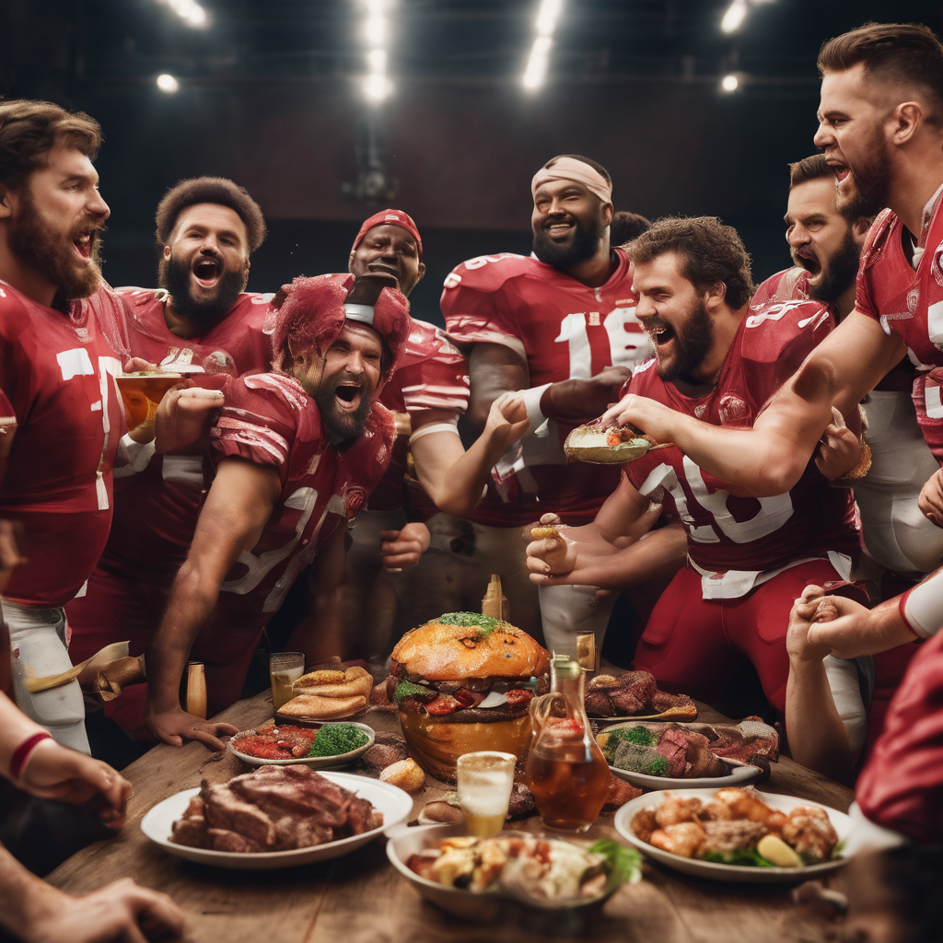

## AI generated image for “Meat-themed fantasy football team celebrating a championship”

Fantasy football at its best is about great players putting up great performances. If you enjoy the exact opposite, then this was the Dynasty title run for you!

Meat’s (incomplete) lineup narrowly defeated Jay’s (incomplete) lineup 81.4-80.2 to win the 2023 Dynasty championship. A combined two inactive players were started, setting a Dynasty title game record I never wanna see again. Meat barely weathered a furious Jordan Love comeback attempt to win the closest championship game ever, with the past two title games now producing the largest (50.2) and smallest (1.2) margins of victory in league history.

This is now Meat’s 3rd Dynasty championship, and 2nd straight title won due to an inactive player started by his playoff opponent (along with 2016). Both came as the #5 seed, now the playoff seed with the most league titles (six!). In a three-game title run even Milton Berle would be proud of, Meat scored a combined 249.1 pts (83/gm, lowest scoring title run ever) failing to reach 85 pts in any game. For comparison, tough luck runner-up Jay Carroll scored 268.5 pts (134/gm) in the first two rounds alone. I say it every year and it’s never been more true – literally *any* team can luck their way to a league title. Just find a way to make the playoffs!

Unfortunately for Mike Kerkel, he takes over as the unluckiest team that’s yet to win a title. With a historic 13-1 record and the 2nd highest total pts / 4th highest per game score ever (1,520.8 pts/108.6 ppg), a season for the ages ends up short of the finish line again. The team still named after formerly rostered player & commissioner favorite Ezekiel Elliott picked an inopportune time to register its lowest scoring game of the entire season. This marks the 4th consecutive year Kerkel finished top 3 in scoring, yet all four playoff runs ended in the semi-finals. Better luck ahead Mike, and congrats on the record-breaking season & on constructing a true dynasty squad.

The other teams in the playoff field included a strong Dave Nickelsen #2 seed, 4th-seeded defending champ Hawke, and a 5-9 Jeremiah squad – the first (and probably last) 5-win Dynasty playoff team ever. Four 5-win teams had a chance to clinch a playoff spot with a win in Rivalry Week 14 – Jeremiah, Steve, Twitch, and Toot. All four promptly lost. Jeremiah backed in anyway. Jason’s win over Jeremiah that week pushed his record to 2-12, narrowly avoiding the worst record in league history (1-12, 2011 Mr. Shannon Anderson). Inspiring fun fact: Shannon would make the playoffs the very next year, and even win the 2013 championship just two years later, with no help from his 2012 1st overall pick either (Trent Richardson). That 2013 Shannon team still remains the last top-scoring team to win the title in the same year, now 0 for the last 10.

Thanks again everyone, I truly appreciate it. Have a wonderful 2024!

# **2023 Dodge Dynasty Awards**

**Dodge Dynasty MVP**

Winner: Christian McCaffrey – Jay

Runners-up: Tyreek Hill – Kerkel; CeeDee Lamb – George; Josh Allen – Kerkel; Kyren Williams – Kerkel; Raheem Mostert – Jay; Jalen Hurts – Dave

**Playoff MVP**

Winner: Rachaad White – Meat

Runners-up: Christian McCaffrey – Jay; Jahmyr Gibbs – Jay; David Njoku – Jay

Honorable Mention: Raheem Mostert’s injured ankle – Meat

**Pickup of the Year**

Winner: Kyren Williams – Kerkel

Runners-up: Puka Nacua – Toot; De’Von Achane – Dave; Gus Edwards – Twitch; Jerome Ford – George; Sam LaPorta – George (traded to Jay); Jordan Love – Jay; Brock Purdy – Dave; Zack Moss – Jay; Rashee Rice – Twitch; Jared Goff – Jason

**Sleeper of the Year**

Playing for the team that drafted them

Winner: Raheem Mostert – Jay

Runners-up: Mike Evans – Jeremiah; Nico Collins – Kerkel; Dak Prescott – Steve; C.J. Stroud – Jay; Jayden Reed – George; Michael Pittman Jr. – Dave

**Breakout Player of the Year**

Non-Rookie

Winners: Kyren Williams – Kerkel; Raheem Mostert – Jay

Runners-up: Rachaad White – Meat; DJ Moore – Jason (traded to Dave); CeeDee Lamb – George; Breece Hall – Twitch; James Cook – Dave (traded to Jason); Jordan Love – Jay; Brock Purdy – Dave; Isiah Pacheco – Steve; Brandon Aiyuk – Meat; Nico Collins – Kerkel

**Rookie of the Year**

Winners: Puka Nacua – Toot; Jahmyr Gibbs – Jay

Runners-up: Bijan Robinson – George; De’Von Achane – Dave; C.J. Stroud – Jay; Sam LaPorta – George (traded to Jay); Jayden Reed – George; Jordan Addison – Steve; Rashee Rice – Twitch; Tank Dell – Twitch

**Dodge Dynasty Owner of the Year**

Winner: Mike Kerkel

Runners-up: Jay Carroll; Dave Nickelsen

**Dynasty Survivor Winner**

Winner: Mike Kerkel

Runner-up: Jay Carroll

**Bust of the Year**

Non-Injury

Winners: Austin Ekeler – Jason (traded to Dave); Tony Pollard – Dave (traded to Jason)

Runner-up: Travis Kelce – Toot

**Comeback Player of the Year**

Winner: Keenan Allen – Jeremiah

Runners-up: Dak Prescott – Steve; David Montgomery – Kerkel; Baker Mayfield – Toot

**Comeback From Death Player of the Year**

Winner: Damar Hamlin

**Comeback From Worse Than Death (the NY Jets) Player of the Year**

Winner: Joe Flacco

**Samoan of the Year**

Winner: Puka Nacua – Toot

Runners-up: Tua Tagovailoa – Steve; Jason Mamoa

**Italian Quarterback of the Year**

Winner: Joe Flacco

Runners-up: Tommy DeVito, Jimmy Garoppolo

**French Running Back of the Year**

Winner: Travis Etienne – Kerkel

Runners-up: Zach Charbonnet – Steve; Pierre Strong

**Small is the New Big**

Winner: De’Von Achane – Dave

Runners-up: James Cook – Jason; Keaton Mitchell; Jaleel McLaughlin; Unsuccessful dating profiles

**Old is the New Young**

Winner: Raheem Mostert – Jay

Runners-up: Derrick Henry – Meat; Keenan Allen – Jeremiah; DeAndre Hopkins – Meat; Joe Flacco

**Shitty is Still Shitty**

Winner: Zach Wilson

Runner-up: Mac Jones

**Would be more respected if he went by Andrew**

Winner: Drew Lock

Runner-up: Andy Dalton

**First names that could be spelled more efficiently by using initials**

Winner: CeeDee Lamb – George

Runners-up: DeeJay Dallas; Jaycee Horn; Tee Higgins – Jason

**Waterford Crystal Award**

Very high quality, made of glass

Winner: De’Von Achane – Dave

**Not to overreact but the electric chair would still not be enough**

Winner: Arthur Smith

**Michael Thomas Non-Season-Ending, Season-Ending Injury Award**

Winner: Keenan Allen – Jeremiah

**Closest NFL/Dodge Dynasty Name Doppelgangers**

Winner: [Jay Carroll](https://www.pro-football-reference.com/players/C/CarrJa20.htm)

Runners-up: [Steven Miller](https://www.pro-football-reference.com/players/M/MillSt00.htm), [Jason Bratton](https://www.pro-football-reference.com/players/B/BratJa20.htm), [David R. Nixon](https://www.pro-football-reference.com/players/N/NixoDa20.htm), [Matt Robinson](https://www.pro-football-reference.com/players/R/RobiMa01.htm), [George Hays](https://www.pro-football-reference.com/players/H/HaysGe20.htm), [Mike Kirkland](https://www.pro-football-reference.com/players/K/KirkMi00.htm), [Gerry Perry](https://www.pro-football-reference.com/players/P/PerrGe21.htm), [Dan Turk](https://www.pro-football-reference.com/players/T/TurkDa20.htm), [Jeremiah Valoaga](https://www.pro-football-reference.com/players/V/ValoJe00.htm)

**Jameis Winston/Blake Bortles/Gus Frerotte Award**

Keeping both teams in it

Winner: Sam Howell – Jeremiah

Runner-up: Nick Mullens

**The New Todd Gurley (first 4 years)**

Winner: Kyren Williams – Kerkel

**The New Todd Gurley (final 2 years)**

Winner: Dameon Pierce – Jason

**Broncos Country, Let’s Reduce Liability**

Winner: Russell Wilson benching

**I saw two big fat naked bikers in the woods off seventeen having sex. How am I supposed to chip with that going on?**

Winner: Shooter McGavin

**2023 Dodge Dynasty Playoff Results (available** [**here**](https://fantasy.espn.com/football/league/playoffs?leagueId=275479)**)**

**Dodge Dynasty History (available** [**here**](http://startdrafting.com/Draft/History)**)**

# **Perfect Lineups**

# **Next Year’s Draft Order**

Draft order for every round (excluding any 1st round comp picks)

1. Bratten
2. Toot
3. Twitch
4. Steve
5. Jeremiah
6. George *
7. Dave
8. Kerkel
9. Jay
10. World Champion MEAT **

* George's 7th round pick traded to Jay; George receives Jay's 15th round pick

** Meat’s 9th round pick traded to Jay; Meat receives Jay's 13th round pick

# **Adjusted Total Points (used for Non-Playoff Draft Order)**

